Snowflake UPI Fraud Monitoring Solution Architecture & BRD
Version 1.0
Domain
UPI / Digital Payments Fraud Monitoring
Platform
Snowflake Data Cloud
Detection Approach
Rule-Based Fraud Monitoring

1. Executive Summary
The objective of this solution is to implement an enterprise-grade fraud monitoring platform for UPI and digital payments on Snowflake.
The platform will:
- Monitor UPI transactions in near real time
- Detect suspicious customer behavior using predefined fraud rules
- Generate fraud alerts for investigation teams
- Provide customer risk scoring
- Support regulatory reporting and compliance
- Enable fraud analytics through Power BI dashboards
The architecture follows a Medallion (Bronze, Silver, Gold) data model implemented in Snowflake.

2. Business Objectives
The solution aims to:
- Reduce fraud losses
- Detect unauthorized transactions
- Prevent account takeover
- Identify mule accounts
- Improve fraud investigation efficiency
- Provide centralized fraud management
- Support AML and compliance initiatives

3. Business Scope
In Scope
UPI Transactions
- P2P transfers
- P2M payments
- Merchant payments
- QR code transactions
- Collect requests
Customer Activities
- Mobile logins
- Device registrations
- Password changes
- Beneficiary additions
Fraud Monitoring
- Velocity fraud
Monitoring the frequency and pattern of transactions made within a specific time frame and checking for unusual activity, such as an abnormally high number of transactions from a single account.
- Device fraud
Device fraud in UPI refers to fraudulent activities that occur on the device used to access the UPI system. This can include unauthorized access to the device, such as through malware or physical theft, which allows fraudsters to manipulate the UPI system.
- High-value transfers
High-value transfers in UPI refer to transactions that exceed a certain threshold, typically set by the Reserve Bank of India (RBI). These transfers are subject to enhanced scrutiny and may require additional verification steps to prevent fraud and money laundering
- Geo-location anomalies
Irregularities in customer location on Unified Payments Interface (“UPI”) applications.
- Mule account detection
A mule account in UPI refers to a legitimate-looking bank account used by criminals to receive and transfer illicit funds. These accounts are often used in money laundering schemes, acting as a transit point for stolen money.

4. Source Systems
UPI Transaction System
transaction.csv
transaction_id
upi_ref_no
customer_id
account_id
payer_vpa
payee_vpa
beneficiary_id
merchant_id
txn_datetime
txn_amount
txn_status
txn_type
channel
device_id
ip_address
latitude
longitude

Customer Master
customer_master.csv
customer_id
customer_name
DOB

GENDER

mobile_number

Email_id

customer_segment
customer_type

kyc_status
risk_rating
customer_since
customer_status

Account Master
account_master.csv
account_id
customer_id
account_number
account_type
branch_code
ifsc_code
open_date
account_status
current_balance
available_balance

Device Registry
device_registry.csv
device_id
customer_id
imei_number
imsi_number
sim_number
device_make
device_model
device_os
os_version
app_version
device_fingerprint
trusted_flag

Login Activity
login_activity.csv
login_id
customer_id
device_id
login_time
login_status
ip_address
country
state
city

Beneficiary Master
beneficiary_master.csv
beneficiary_id
customer_id
beneficiary_name
beneficiary_vpa
bank_name
risk_rating

Merchant Master
merchant_master.csv
merchant_id
merchant_name
merchant_category
merchant_status
risk_rating

Watchlist
watchlist.csv
watchlist_id
entity_type
entity_name
risk_level

Collect Request
CollectRequest.csv
Collect_request_id
Customer_id
Request_amount
Request_time
Request_status

Password
Password.csv
Password_change_id
Customer_id
change_time
change_channel
device_id
- HHigh-Level Architecture
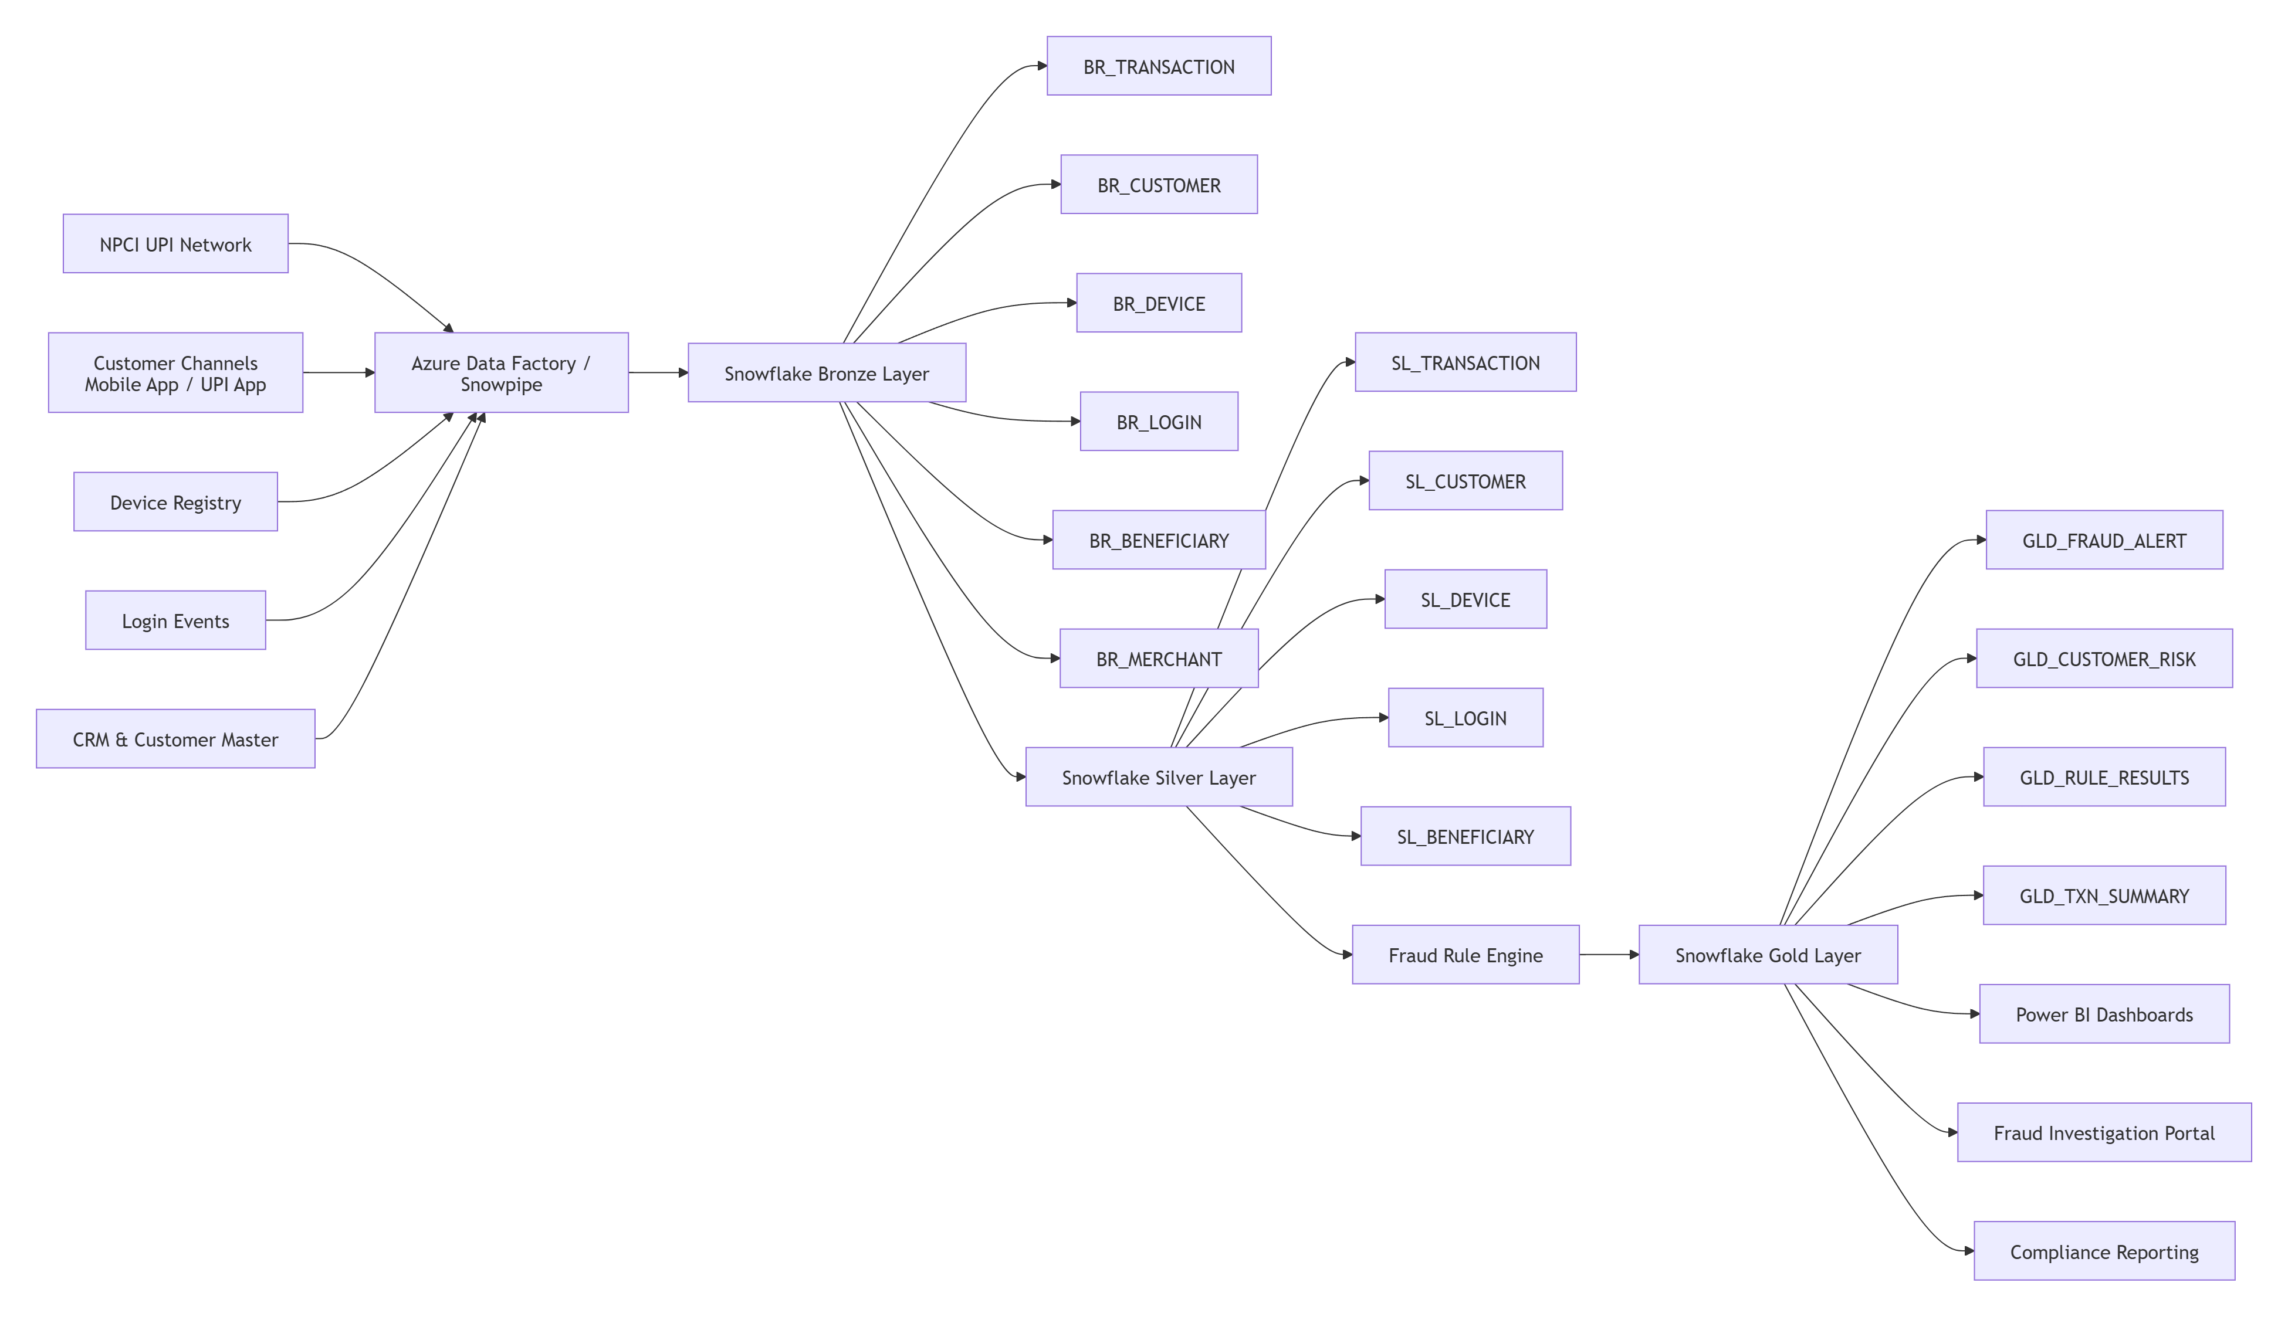

6. Medallion Architecture

Bronze Layer
Purpose
Store raw, immutable source data.
Tables
BR_TRANSACTION
BR_CUSTOMER
BR_ACCOUNT
BR_DEVICE
BR_LOGIN
BR_BENEFICIARY
BR_MERCHANT
BR_WATCHLIST
BR_COLLECT_REQUEST
BR_PASSWORD_CHANGE

Silver Layer
Purpose
Store cleaned and enriched datasets.
Processing Activities
- Deduplication
- Standardization
- Data quality validation
- Customer enrichment
- Device enrichment
- Geo enrichment
Tables
SL_TRANSACTION
SL_CUSTOMER
SL_ACCOUNT
SL_DEVICE
SL_LOGIN
SL_BENEFICIARY
SL_MERCHANT
SL_WATCHLIST
SL_COLLECT_REQUEST
SL_PASSWORD_CHANGE

Gold Layer
Purpose
Store fraud-ready analytical datasets.
Tables
GLD_FRAUD_ALERT
GLD_RULE_RESULTS
GLD_CUSTOMER_RISK
GLD_TXN_SUMMARY
GLD_INVESTIGATION_QUEUE
GLD_FRAUD_DASHBOARD

7. Logical Data Model
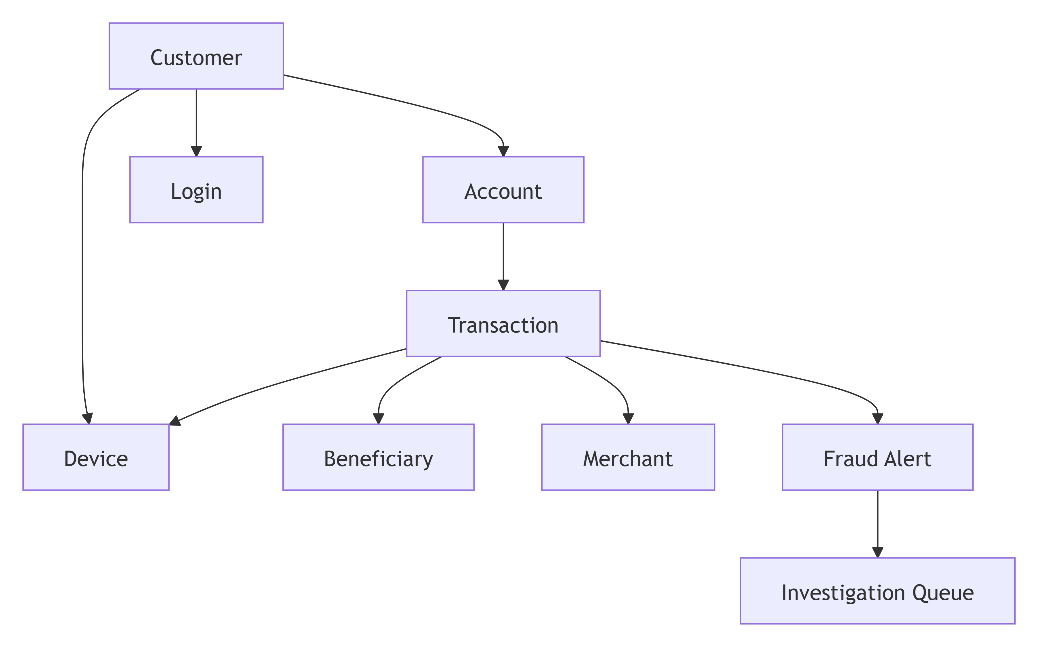

8. Snowflake Data Model
Source Systems
↓
Bronze Layer (RAW_DB)
↓
Silver Layer (CURATED_DB)
↓
Fraud Rule Engine
↓
Gold Layer (FRAUD_DB)
↓
Fraud Portal / Compliance

Databases

Schemas
BRONZE
SILVER
GOLD

Warehouses
WH_FRAUD

9. Fraud Rules Catalog
FR001 High Value UPI Transaction
Condition:
Severity: HIGH
Risk Score: 90

FR002 Transaction Velocity
Condition:
SQL
More than 10 transactions
within 5 minutes
Severity: HIGH
Risk Score: 95

FR003 Multiple Beneficiaries
Condition:
15 unique beneficiaries
within 1 hour
Severity: HIGH
Risk Score: 85

FR004 First-Time Beneficiary High Value
Condition:
First transfer
AND
Amount > 50000
Severity: HIGH
Risk Score: 90

FR005 New Device Transaction
Condition:
Risk Score: 80

FR006 Device Change Plus High Value
Condition:
New Device
AND
Amount > 50000
Risk Score: 95

FR007 Impossible Travel
Condition:
User logs in from two geographically distant locations within a short duration.
Example:
Hyderabad
to
Singapore
within 2 minutes
Risk Score: 95

FR008 Dormant Account Activity
Condition:
Risk Score: 90

FR009 Failed Login Attempts
Condition:
More than 5 failures
within 10 minutes
Risk Score: 85

FR010 Midnight Transactions
Condition:
Transaction between
00:00 and 04:00
Risk Score: 75

FR011 Blacklisted Beneficiary
Condition:
Beneficiary exists in watchlist
Risk Score: 100

FR012 Blacklisted Merchant
Condition:
Merchant exists in watchlist
Risk Score: 100

FR013 Unusual Geo Location
Condition:
Transaction from a new state or country.
Risk Score: 80

FR014 Rapid Balance Depletion
Condition:
80% balance reduction
within 30 minutes
Risk Score: 100

FR015 Collect Request Abuse
Condition:
Risk Score: 70

FR016 QR Payment Fraud
Condition:
Unknown Merchant
AND
High Amount
Risk Score: 85

FR017 Account Takeover Pattern
Condition:
Password Change
Device Change
High Value Transfer
Risk Score: 100

FR018 Mule Account Pattern
Indicators:
- Receives from many customers
- Immediate outward transfers
- Very low average balance
Risk Score: 100

FR019 Beneficiary Velocity
Condition:
More than 20 customers
sending money
to same beneficiary
Risk Score: 95

FR020 Circular Transactions
Pattern:
A -> B
B -> C
C -> A
within 24 hours
Risk Score: 100

10. Gold Alert Table Design
SQL

CREATE TABLE GLD_FRAUD_ALERT
(
ALERT_ID VARCHAR,
RULE_ID VARCHAR,
CUSTOMER_ID VARCHAR,
TRANSACTION_ID VARCHAR,
RISK_SCORE NUMBER,
SEVERITY VARCHAR,
ALERT_STATUS VARCHAR,
CREATED_TS TIMESTAMP
);

11. Fraud Alert Workflow

UPI Transaction
↓
Data Validation
↓
Fraud Rule Engine
↓
Risk Scoring
↓
Fraud Alert Creation
↓
Investigation Queue
↓
Fraud Analyst Review
↓
Close / Escalate / Block

12. Power BI Dashboards
Executive Dashboard
KPIs
- Total Transactions
- Total Alerts
- Fraud Amount
- Fraud Prevented
- Customer Risk Score

Investigation Dashboard
KPIs
- Open Alerts
- Resolved Alerts
- SLA Breaches
- Avg Investigation Time

UPI Fraud Dashboard
KPIs
- Fraud by State
- Fraud by Device
- Fraud by Merchant
- Fraud by Beneficiary
- Fraud by Rule

13. Security Controls
Authentication
- SSO
- MFA
Authorization
- RBAC
- Row-Level Security
Data Protection
- Encryption at Rest
- Encryption in Transit
- Tokenization
Monitoring
- Audit Logs
- User Activity Tracking

14. Non-Functional Requirements
Requirement | Value
Availability | 99.9%
Latency | <60 Seconds
Daily Volume | 100 Million Transactions
Data Retention | 7 Years
Scalability | Horizontal
Security | Enterprise Grade

15. Expected Benefits
- 30% to 50% reduction in fraud losses
- Real-time fraud detection
- Faster fraud investigations
- Improved customer trust
- Enhanced regulatory compliance
- Centralized UPI fraud monitoring platform

